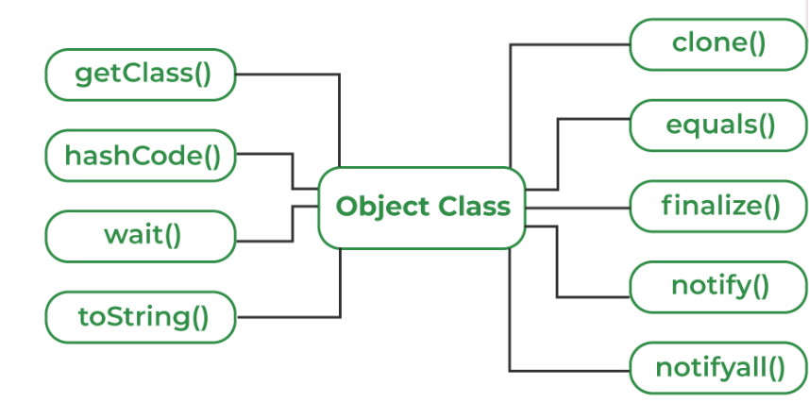1) toSring()
class Student{
String name = "Vishnu";
int age = 21;
@Override
public String toString(){
return "Student{name='" + name + "', age=" + age + "}";
}
public static void main(String[] args) {
Student s = new Student();
// Calls overridden toString()
System.out.println(s.toString());
}
}
====================================================================================
2) hashcode()

class Employee{
int id = 101;
@Override
public int hashCode(){

return id * 31; // Simple custom hash
}
public static void main(String[] args) {
Employee e = new Employee();
System.out.println(e.hashCode());
}
}
=====================================================================================
3) equals()
class Book{
String title;
Book(String title) {
this.title = title;
}
@Override
public boolean equals(Object obj){
Book b = (Book) obj;
return this.title.equals(b.title);
}
public static void main(String[] args) {
Book b1 = new Book("Java");
Book b2 = new Book("Java");
System.out.println(b1.equals(b2)); // true
}
}

4) getClass()

public class Geeks{

public static void main(String[] args)
{
Object o = new String("GeeksForGeeks");
Class c = o.getClass();
System.out.println("Class of Object o is: "
+ c.getName());
}
}
====================================================================================
5) finalize()
public class Geeks {
public static void main(String[] args) {
Geeks t = new Geeks();
System.out.println(t.hashCode());
t = null;
// calling garbage collector
System.gc();
System.out.println("end");
}
@Override protected void finalize()
{
System.out.println("finalize method called");
}
}

6) clone()
class Student implements Cloneable{
int id = 1;
String name = "Vishnu";
@Override
public Object clone() throws CloneNotSupportedException{
return super.clone(); // shallow copy
}
public static void main(String[] args) throws Exception{
Student s1 = new Student();
Student s2 = (Student) s1.clone();
System.out.println(s1.name); // Vishnu
System.out.println(s2.name); // Vishnu
}
}

